Team Name: Data Cognito Agents
Focused on: Best Use of Salesforce Data Cloud
Purpose:
“This handout gives a quick look at how we used Salesforce Data Cloud and Agentforce to turn a simple online cart abandon into a real-world retail win—powered by smart data, segmentation, and agent actions”.
Project Title: BlueTails – ELEVATING RETAIL Personalized Journeys - Powered by Data Cloud & Agentforce
Problem Statement:
- Retail brands lose potential customers through abandoned carts online.
- Lack of real-time, personalized intervention leads to missed sales opportunities.
- Online and offline customer journeys often remain disconnected. Loyalty Reward Management
Our Solution:
- Salesforce Data Cloud powers unified customer profiles from website browsing, cart behavior, and in-mall beacon detection.
- Agentforce empowers agents to receive real-time alerts and customer insights to proactively engage and close the loop.
- Personalized offers are dynamically crafted based on customer loyalty, behavior, and proximity.
Solution Architecture:
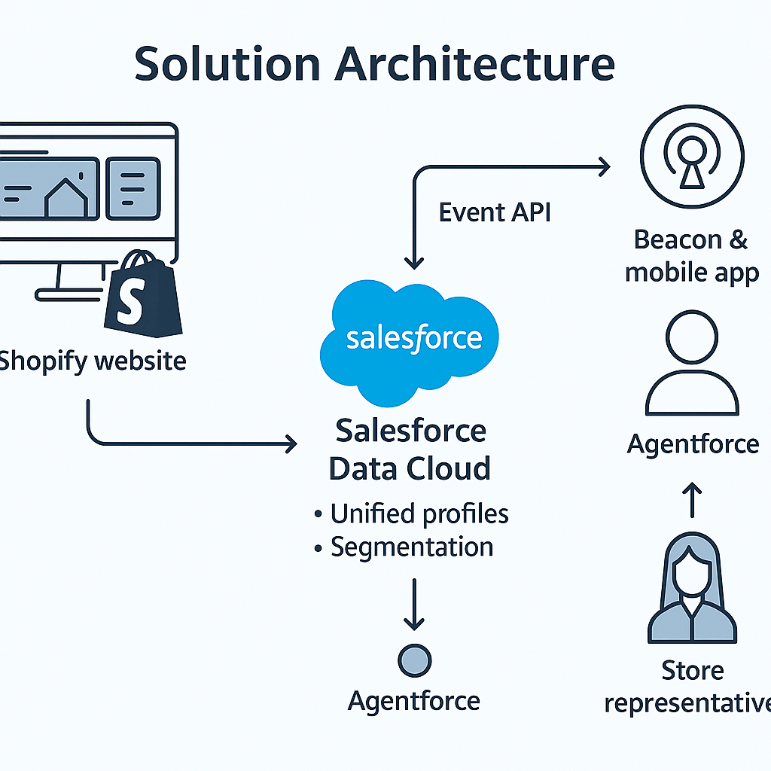

Story Highlight: David’s Journey:
- Browsed Smartwatch on BlueTails Website → Cart Abandon
- Real-time segmentation → Agent alert
- Random visit to LULU Mall → Beacon detected via BT Mobile App
- Agent crafts personalized offer → In-store purchase success
- Post-Purchase → David Requests Sunglasses (Out of Stock)
- Agentforce Search → Mark Locates Nearest Store Using David's Zipcode
- Shares Nearby Store Info + Additional Discount on Sunglasses
- Converts Out-of-Stock Inventory to New Opportunity
- Sees David’s Loyalty Tier Upgrade (Gold ➔ Platinum) → Updates in CRM
- David Leaves as a Happy Platinum Member, Mark Achieves Multiple Wins: Cart Recovery + Inventory Recovery + Loyalty Upgrade
Key Outcomes:
Key Outcome | Business Impact
Abandoned Cart Recovered | Increased Revenue
New Opportunity from Out-of-Stock Item | Inventory Optimization
Loyalty Tier Upgraded | Customer Retention Boost
Empowered Agent (Mark/Sarah) | Service Excellence

Why Our Solution Wins:
- ZIP-based Inventory Intelligence
- Beacon Activation + Segmented Insights
- Loyalty-Aware Recommendations
- Real-Time Actionable Insights
- Intelligent Agent Assistance
- True Online + Offline Customer Unification

